

**Partnership with Help Me Grow-Help Me Thrive North Texas**

**Overview**

**Help Me Grow North Texas** is proud to be an affiliate of Help Me Grow, a national evidence-based model that works to promote collaboration across child-serving sectors in order to build a more efficient and effective system that promotes the optimal healthy development of young children ages 0 to 5. Help Me Grow serves to promote optimal development of all young children and identify those with developmental concerns as early as possible and connect them with appropriate services and interventions.

**Help Me Thrive North Texas** is a local enhancement of the Help Me Grow model but focusing on youth aged 6 to 17 in North Texas to also promote optimal development of youth and connect their families with appropriate services and interventions.

**Four cooperative core components characterize the**

**Help Me Grow-Help Me Thrive system model:**

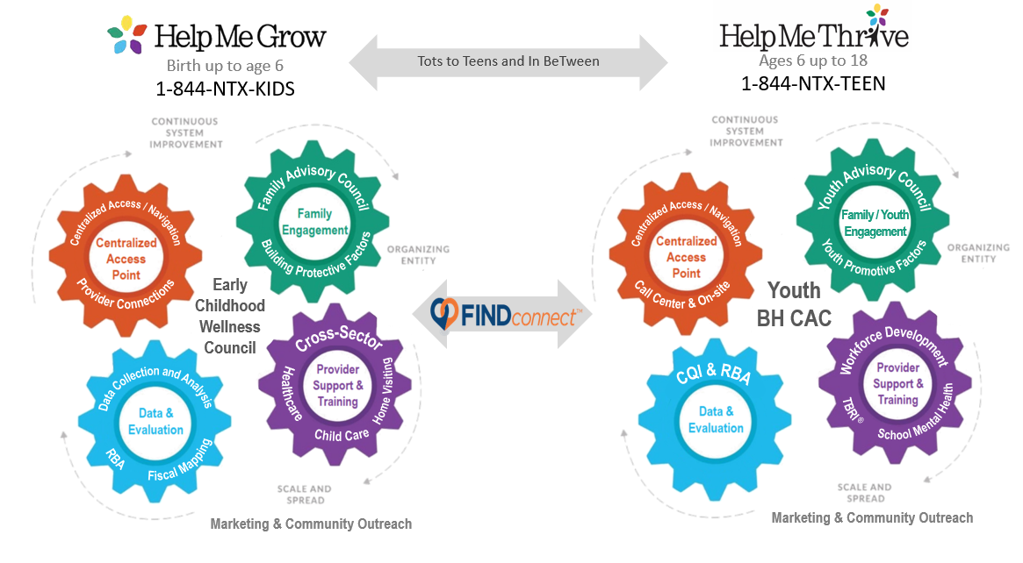

1. A **Centralized Access Point** (CAP) assists families and providers in connection to community-based programs and services.
2. **Family and Community Outreach** promotes family engagement and leadership as well as outreach to the community about services, programs and events.
3. **Provider Support and Training** links early childhood & youth service providers to high-quality training and supports developmental screening and intervention efforts.
4. **Data Collection & Analysis** supports evaluation, helps identify systemic gaps, bolsters advocacy efforts, and guides continuous quality improvement.

**Benefits of Partnership**

Help Me Grow & Help Me Thrive system of care models offer a variety of benefits to community agencies and individuals:

1. Quality materials and trainings to support optimal child & youth development
2. Bi-directional referrals for family serving organizations through the FINDconnect system
3. Support in implementation and/or expansion of developmental screening practice
4. Contribute to collective impact efforts to improve outcomes for all North Texas families
5. Increase equitable access to quality programs for marginalized families
6. Provide expertise to improve early childhood-youth serving systems
7. Support in implementation and/or expansion of family and youth engagement and leadership

**Partnership Pledge**

Thank you for your interest in partnering with us. Please feel free to check as many of the boxes that pertain to you or your organization.

As a partner of Help Me Grow North Texas-Help Me Thrive, I pledge to:

Implement a developmental screening practice for young children

Promote universal (meaning “to all”) developmental screenings

Promote optimal, healthy child & youth development

Share about Help Me Grow-Help Me Thrive with families and community partners

Follow the process to be listed as a resource in our FINDconnect directory with the acknowledgement that you will be contacted quarterly for any resource updates

Identify service gaps and barriers within the community/region

Attend general collaborative meetings twice a year

Participate in one or more of the five subcommittees that meet quarterly (Data, Marketing, Centralized Access, Provider Support & Training, & Family Engagement)

Attend the Early Childhood Wellness Council (western side of region), the Family Wellness Council (eastern side of region), or the MHMR Tarrant Youth Community Advisory Committee

Recommend/or become a Family or Youth Partners for HMG or HMT

* Click [here](https://docs.google.com/forms/d/e/1FAIpQLSd92_JjsdIqfKfIlcwbRWhZfiQ8AaJfc4nx8CgXMhLgLtdmOg/viewform?usp=share_link) for more information on family partner engagement

Offer evidence-based trainings to the community

Other:

               

Partner Name Partner Agency

     

Partner Contact Information              Date

If you have questions related to the partnership pledge or would like to submit your pledge, please email us at [Info@HelpMeGrowNorthTexas.org](mailto:Info@HelpMeGrowNorthTexas.org) for Help Me Grow or [Info@HelpMeThriveNorthTexas.org](mailto:Info@HelpMeThriveNorthTexas.org) for Help Me Thrive. You can also fill out the pledge in a survey form by clicking on [this link](https://docs.google.com/forms/d/e/1FAIpQLSca9WyvHmZG6sSIyF0rSua3w7O2VgJSRpCgV7IB4lCpwDiXnA/viewform?usp=sf_link).

After your partner pledge has been received, a Help Me Grow staff or leadership team member will contact you with next steps to support your partnership.

You can find more information on our websites and social media:

Help Me Grow North Texas

[www.HelpMeGrowNorthTexas.org](http://www.helpmegrownorthtexas.org)

844-NTX-KIDS

](https://www.instagram.com/helpmegrowntx/)

Help Me Thrive North Texas

[www.HelpMeThriveNorthTexas.org](http://www.helpmethrivenorthtexas.org)

844-NTX-TEEN

](https://www.instagram.com/helpmethrivenorthtexas/)

